Collaborator Data Index Document

Authors
Name | Affiliation
Michael Youdell | Oxford University
Andrew Blake | Oxford University
Enric Domingo | Oxford University
James Robineau | Oxford University
Tim Maughan | Oxford University

SUMMARY

This document summarises the larger datasets that have been generated through S:CORT and are available for partners for collaboration.

Table of Contents
1 List of Figures 3
2 List of Tables 3
3 Introduction 4
4 Sample Selection 5
5 Oxaliplatin Response 6
6 Radiation Therapy Response 8
7 Cetuximab Response 10
8 Sample preparation 12
9 DNA Mutation 13
10 RNA Profiling 17
11 mDNA Profiling 21
12 Patient Data 23
13 Data Integration QC 24
14 Appendix 1 – DNA Methylation Workflow 25
15 Appendix 2 – RNA Analysis Summary 26
16 Appendix 3 – Common Patient Data Fields 27
17 References 30

List of Figures
Figure 1 - Summary of Sample Pathways 4
Figure 2 Oxaliplatin Response Sample Attrition Summary 7
Figure 3 Radiation Therapy Response Sample Attrition Summary 9
Figure 4 Cetuximab Response Sample Attrition Summary 11

List of Tables
Table 1 - Sample Origin 5
Table 2 - Summary of FOCUS samples selected for S:CORT analysis 6
Table 3 - Sanger S:CORT Sequencing Panel v2. 16

Introduction

The S:CORT Consortium is funded by MRC and CR-UK to assess DNA mutations, morphology, RNA expression, Immunohistochemistry and DNA methylation profiles in 2000 colorectal cancer (CRC) patients. In the majority of cases Formalin Fixed Paraffin Embedded (FFPE) blocks containing CRC were identified from clinical trials or patients on standard care and were subsequently sectioned and processed. Sections were sent to Queen’s University, Belfast or Almac for RNA expression profiling. DNA was extracted and sent to the Sanger Institute and Birmingham University for DNA mutation and methylation profiling respectively. Immunohistochemistry was carried out at the University of Leeds and Queens University Belfast. All molecular, phenotypic and patient data have been compiled in Oxford for distribution and visualization. This pipeline is summarized in Figure 1. More details for the platforms and methods used to derive, interrogate, QC and visualize the data can be found in sections 8 to 12.

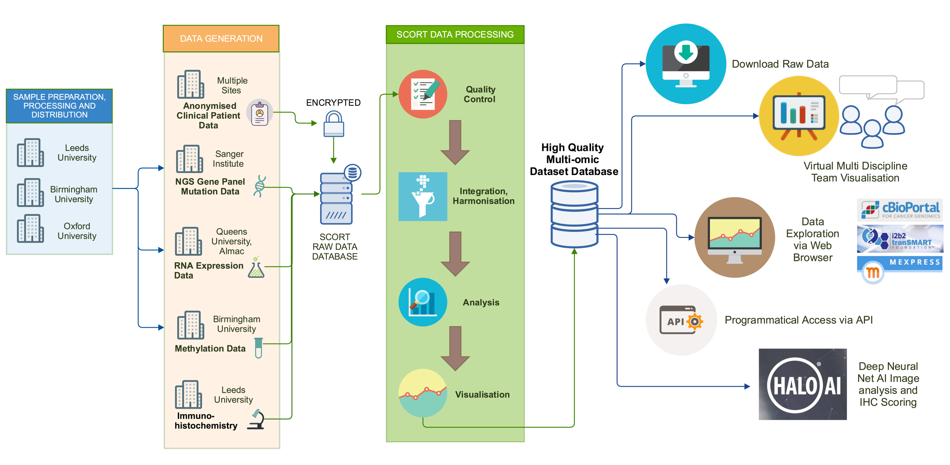

Figure 1 - Summary of Sample Pathways

Sample Selection

The origin of the samples for the 3 main datasets for which data is available are summarized in the table below:

Cohort Name | Cohort Origin | Patients | Notes
Oxaliplatin Response | FOCUS clinical Trial | 411 | A phase 3 study in metastatic CRC patients. We analysed primary resection samples from patients who received 5FU or 5FU+Oxaliplatin as first line chemo for metastatic disease.
Radiation Therapy Response | Grampian NHS Diagnostic Archive | 265 | Rectal patients who only received neoadjuvant radiation with or without chemotherapy for which pre-treatment biopsies were sourced.
Cetuximab Response | New EPOC Clinical Trial | 128 | A phase 3 study in CRC patients with resectable liver metastases comparing treatment with standard chemotherapy +/- cetuximab. We analysed paired primary CRC and liver metastasis.

Table 1 - Sample Origin

Oxaliplatin Response
In order to understand in more detail the molecular basis of response to Oxaliplatin, samples from the FOCUS trial were used. This study recruited 2135 patients between May 2000 and Dec 2003 and tested various combinations and sequences of oxaliplatin and irinotecan with FU alone. We refer to the treatment arms here in the same way as shown in Figure 1 of the main FOCUS paper (Seymour M.T., Maughan T.S et al, Lancet 2007). Ignoring the arm that tested irinotecan use from baseline (arm C-IR, which randomised 356 patients) we have the following S-CORT groups summarised in Table 2 with which to compare the effect of oxaliplatin use over FU alone. We excluded patients who had not given explicit consent to further bowel cancer research, and those with rectal primaries, patients whose diagnosis was only from a biopsy and patients without follow up data to 12 weeks minimum. Figure 2 summarises the sample dropout rates for each assay and the number of patients from whom we have the differing datatypes. In addition, we have digital H&E images and digitised images of the following IHC markers (CD4, CD8, CD56, FOXP3, ICOS, IDO1, PDL1, PD1, CAIX and γH2AX).

 | FOCUS n=411
 | CR/PR* | SD* | PD* | Total
FU alone | 108 | 127 | 90 | 325
Ox+FU | 56 | 19 | 11 | 86
TOTALS | 164 | 146 | 101 | 411
* CR=complete response, PR=partial response, SD=stable disease, PD=progressive disease for 12 week response. Numbers represent eligible patients.

Definition of the S-CORT “FU alone” group
710 patients randomised into FOCUS arm A (FU alone until progression and then IRI; the FOCUS reference arm)
356 into arm B-IR (FU alone until progression and then FU+IRI)
356 into arm B-OX (FU alone until progression and then FU+OX)

Definition of the S-CORT “Oxaliplatin” group
357 into arm C-OX (FU+Ox until progression)

Table 2 - Summary of FOCUS samples selected for S:CORT analysis

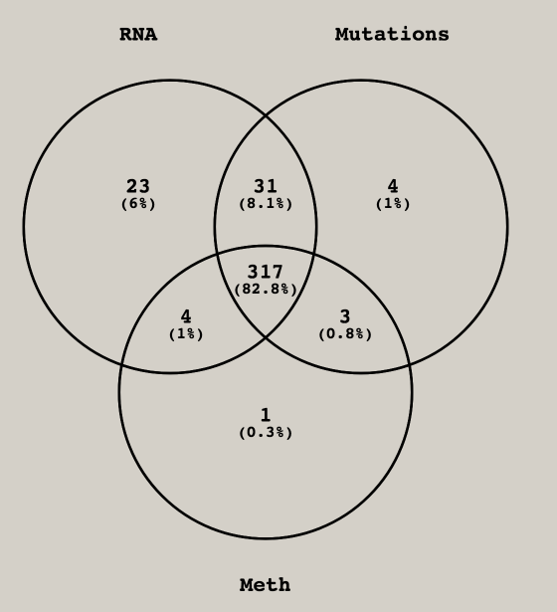

Figure 2 Oxaliplatin Response Sample Attrition Summary

Radiation Therapy Response

This is a series of 265 pre-treatment rectal cancer biopsies sequentially collected from patients treated with radiotherapy with or without chemotherapy in the Aberdeen cancer centre in routine NHS practice. Permission has been granted from the Grampian biorepository for use of the samples. Dr Les Samuel and Prof Graeme Murray (Aberdeen) have selected 135 patients with same treatment regimen (45Gy in 25 fractions over 5 weeks with oral capecitabine) and sufficient tissue to analyse and assessed pathological analysis of the resected tumour after RT as having: complete response (35), good partial response (48), partial response (42) and minimal response (6) as defined below:
- Complete response: complete absence of any microscopic evidence of residual cancer cells.
- Good partial response: There are only small foci of cells as evidence of residual cancer cells.
- Partial response: There is evidence of response to radiotherapy but substantial tumour remains.
- Minimal response: No reduction in tumour volume or tumour progression.

Figure 3 summarises the sample drop out rates for each assay and the number of patients we have with each type of data. In addition, we have digital H&E images for each patient’s tumour. Note that in light of the small volume pre-treatment biopsies there was a significant drop out for the DNA methylation analysis.

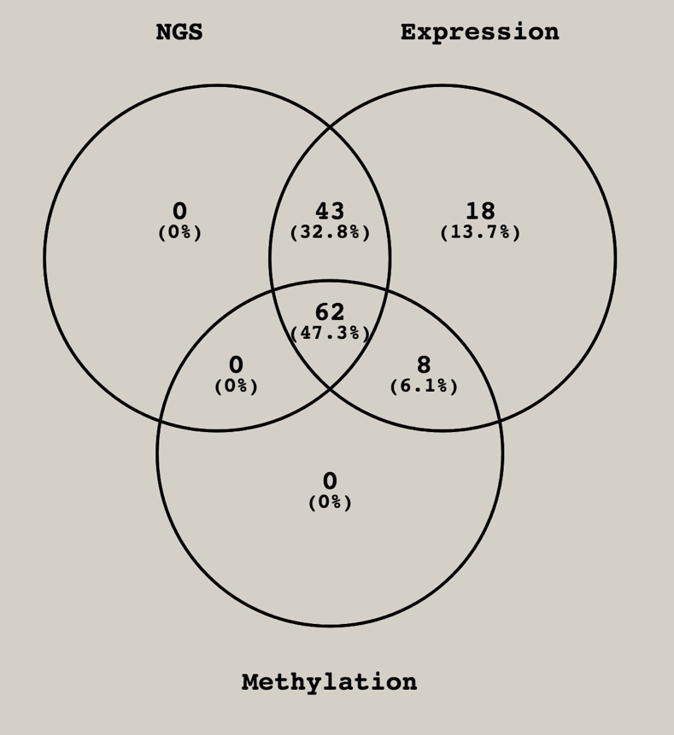

Figure 3 Radiation Therapy Response Sample Attrition Summary

Cetuximab Response

In order to understand in more detail the molecular basis of response to cetuximab, samples from the New EPOC (Primrose et al., 2014) clinical trial were used. Patients with KRAS exon 2 wild-type resectable or sub-optimally resectable colorectal liver metastases were randomised in a 1:1 ratio to receive chemotherapy with or without cetuximab before and after liver resection. This study recruited 272 patients who were randomly assigned to treatment between Feb 26, 2007, and Nov 1, 2012, when the trial was closed having met pre-defined futility criteria. Figure 4 summarises the sample drop out rates for each assay and the number of samples we have which type of data for, which comprises both primary CRCs and liver metastasis. In addition, we have survival/disease progression for each patient and digital H&E images for each patient’s tumour.

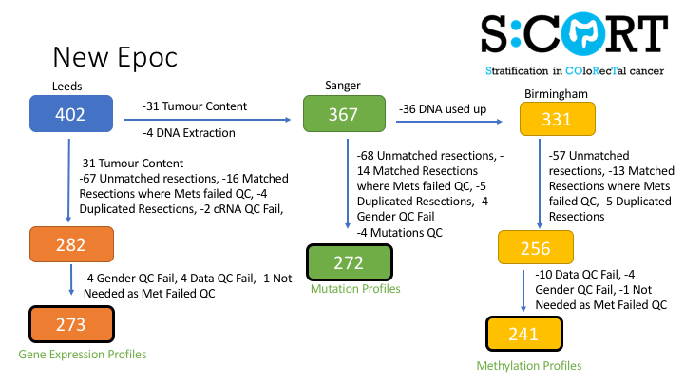
Omic coverage  of the 128 New Epoc  matched pairs | 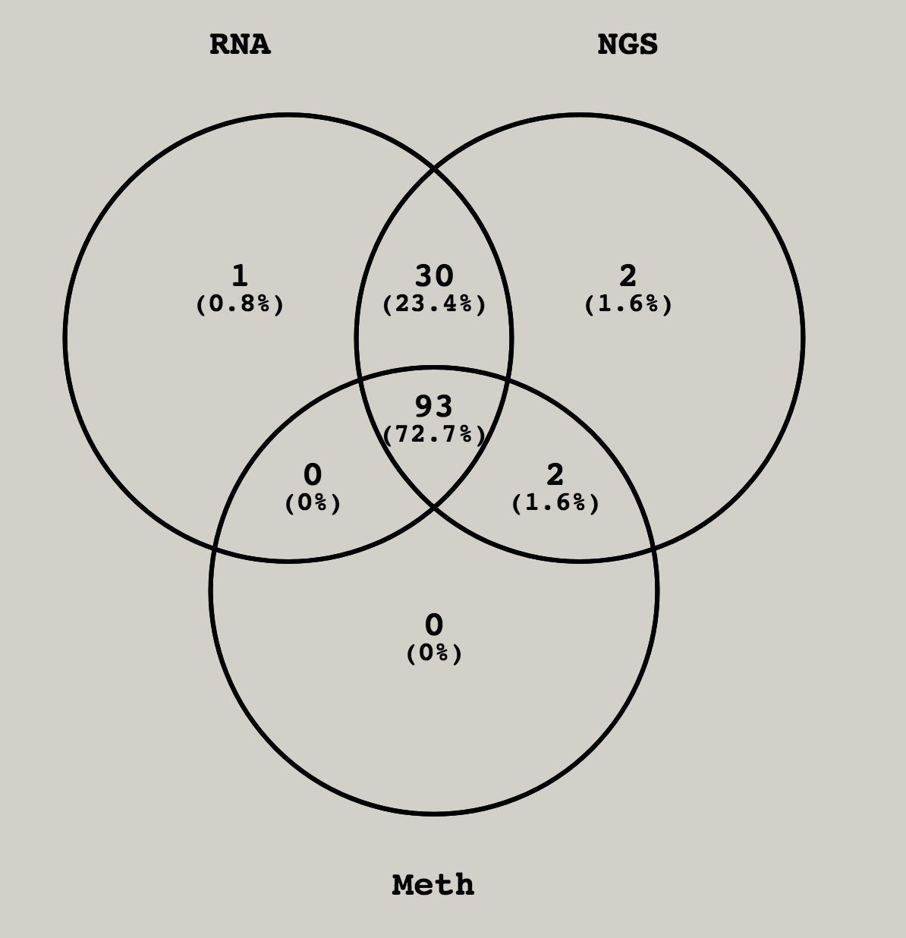

Figure 4 Cetuximab Response Sample Attrition Summary

Sample preparation

Samples were curated in University of Leeds pathology department (Prof Phil Quirke, Susan Richman). Presence of tumour in the sample was confirmed and the samples sections as illustrated below.

Figure 5 Sample sectioning workflow
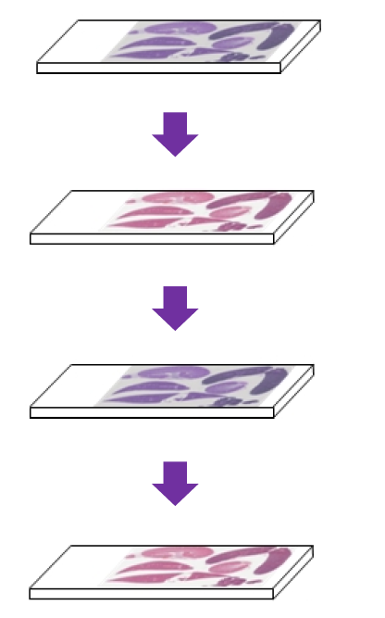
H&E1, image analysis
Marked to guide RNA extraction

RNA extraction (approx.4 slides at 5um)
RNA expression array (Xcel), Almac (Belfast)

H&E2, image analysis
Marked to guide DNA extraction

DNA extraction (approx. 8 slides at 5um)
Targeted NGS (80 CRC driver genes, MSI, CNA), Sanger (Cambridge)
Methylation EPIC array (Illumina), Birmingham

DNA Mutation

DNA was extracted from FFPE samples in Leeds and mutation analysis was performed at the Sanger Institute, Cambridge and the pipeline is summarized in Figure .

Sample Handling Summary
Samples were shipped to the Wellcome Trust Sanger Institute team in FluidX 2-D barcoded tubes along with a sample manifest. Unique Sanger PD IDs were assigned to each sample upon arrival followed by three Quality Control (QC) steps performed by the Core Sample Management team. These steps involved i. Volume check, ii. Picogreen quantification and iii. Fluidigm genotyping in order to assess sample integrity.

Sequencing library preparation and Illumina sequencing
After QC assessment, samples which passed minimum DNA concentration (total DNA >=100ng) and genotyping were submitted for library preparation and Illumina sequencing. Library preparations were performed using the Custom SureSelect Library Prep Kit from Agilent Technologies - Part Number 930075. Libraries were submitted for in-solution capture hybridisation using a custom S:CORT colorectal V2 gene bait set, targeting all coding exons of 80 CRC driver genes (Table 3), 51 regions of recurrent copy number gains/losses (with deeper coverage of 22 cancer genes present in these regions), and 120 MSI regions (mononucleotide repeats). DNA amplification was then performed for 8 cycles before sequencing. Sequencing was performed on Illumina HiSeq2000 machines.

Data analysis
The Illumina sequencing data BAM files were transferred to a dedicated variant calling pipeline developed by the Cancer Group Project (CGP) team for sequence alignment and data analyses. Variant calling algorithms were first run on the data for identification of base insertion/deletions and substitutions in the data – Pindel and Caveman C CGP algorithms). The data was then flagged for variants present only in the list of the cancer genes of the custom bait design as well as for variants seen in germline, FFPE normal samples to remove sequencing artefacts. Further analysis of the data involved flagging for non-synonymous coding variants and driver mutations and also identification of microsatellite instability (MSI). Driver mutations were defined according to whether any given gene was dominant or recessive. For the former, identification was based on comparisons of the S:CORT sample variants with recurrent mutations previously identified in a statistical analysis of 11,119 human tumours, spanning 41 cancer types (Chang et al, Nat Biotechnol, 2016) as well as internally curated driver mutations from the Cancer Genome Project. For recessive genes, we included any truncating mutation (frameshift, nonsense and essential splice) as a putative driver mutation.

The Wellcome Trust Sanger Institute provided the following data to the Oxford repository:
- BAM files (raw sequencing files aligned to the human reference genome),
- vcf files (raw calls for variants),
- flat file showing high quality variants with annotations (e.g. flagged for driver mutations),
- classification of tumours for microsatellite instability (MSI),
- a summary of coverage per tumour.

These files were uploaded via the Globus secure file transfer system and stored on the secure S:CORT fileserver. The original files were stored separately from the decrypted and uncompressed versions of the data to ensure data integrity at every stage of processing and the high quality variants were loaded into the secure MYSQL database held at Oxford. Data for coverage and allelic frequency of each mutation has been added to the database from the vcf files with an R script. Each mutation call and associated individual reads can be visualised from the BAM files using a genome viewer such as IGV.

Figure 6 - Sanger Work Flow

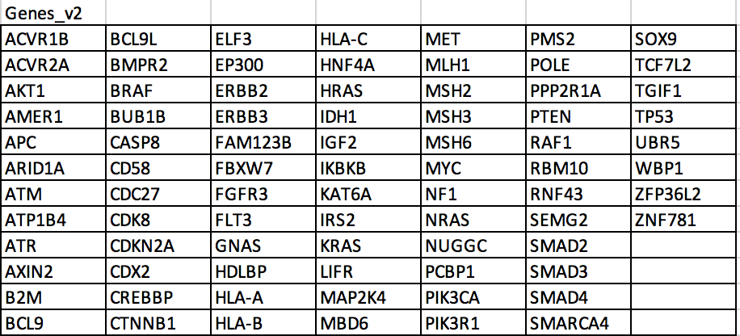

Table 3 - Sanger S:CORT Sequencing Panel v2.

RNA Profiling
RNA Profiling of FFPE tissue
Formalin fixed paraffin embedding (FFPE) is a well-established method for histopathological assessment but results in extensive RNA fragmentation and cross-linking, impacting on RNA profiling. Due to FFPE block processing, specific mRNA transcripts are more susceptible to degradation and the 5' end of the mRNA transcript is more sensitive to FFPE-dependent RNA degradation. To harness the power of large archived clinically annotated cohorts of FFPE tumour blocks, which is central to the S:CORT proposal, we have utilized FFPE-specific IVT reagents and the Almac Xcel Array. These arrays have probe designs focused on the extreme 3' of mRNA (Affymetrix Almac Xcel Array), as these regions are more stable in FFPE tissue. Furthermore IVT reagents specifically designed for FFPE-extracted RNA have been developed including both oligo-dT primers (binding to polyA tails and specific for mRNA) and random hexamers (annealing throughout the target molecule) for first strand cDNA synthesis. This enables amplification at the 3' end and throughout the whole transcript which is more applicable to partially degraded mRNA.

Sample Handling Summary
At the Leeds University sample processing centre, 1 x 5 micron and 2 x 10 micron sections were prepared from all samples which had passed initial histology QC. The 5 micron section was H&E stained followed by annotation of the tumour region by a qualified pathologist. The H&E stained 1 x 5 micron and 2 x 10 micron sections were shipped at room temperature to Queens. Upon sample receipt, the material transfer agreement was completed and returned to Leeds, specimens were registered on a Queens SCORT processing database followed by registering all Human Tissue Act (HTA) relevant material on the Queens HTA database.

Sample Macrodissection
Samples were dewaxed and macrodissected following SCORT-SOP-002-Macrodissection-and-RNA-Extraction. In short, dewaxing of samples was performed by an automated dewaxing process using the Tissue-Tek Prisma®/Film machine. This incorporated 3 xylene washes of 2, 2 and 1 min followed by 2 washes in 95% and 90% ethanol respectively. Macrodissections were performed within a designated macrodissection area treated with an RNase Decontamination Solution. The unstained section was overlaid on top of the H&E reference slide and using a clean scalpel blade the annotated area was scraped into a 1.5 ml RNase-free Eppendorf tubes containing the prepared Roche High Pure RNA Paraffin Kit tissue lysis reagent (Catalogue 03270289001).

Sample RNA Extraction
The Roche High Pure RNA Paraffin Kit instructions for use (Version 12) were followed for RNA extractions. Following RNA extraction, SCORT-SOP-003- Nucleic Acid Quantification was followed detailing quantification of the total RNA using the Nanodrop set to the RNA-40 parameter. Total RNA extraction, quantification and -80ºC storage location details were logged onto the SCORT Specimen Receipt Records spreadsheet.

Preparation of fragmented and labelled cDNA from total RNA
After RNA quantification, samples which had sufficient RNA concentration (≥ 10 ng/µl) were submitted for RNA profiling. The SCORT-SOP-004-3' IVT Pico Kit which details the GeneChip® 3' IVT Pico Reagent Kit (Part No. 703308; Version 1) instructions for use was followed.

Hybridisation, Scanning of Array and Storage of Subsequent CEL Files
SCORT-SOP-005-Cartridge Array Hybridisation & Sample Registration was followed to hybridise the fragmented and labelled cDNA to the microarrays. Following a 16 hour overnight hybridisation the arrays were washed and stained following the SCORT-SOP-006- Fluidics_Start Up_ Wash_Stain_ShutDown. SCORT-SOP-007-Scanning of Array and Storage of CEL Files was performed to scan the hybridised arrays and to ensure the resulting image (CEL) files were securely backed up offsite to eliminateg the risk of catastrophic data loss.

Quality control assessment of CEL Files
The protocol entitled ‘SCORT-SOP-008-Analysis of CEL Files to Determine QC Metrics‘ was followed to assess QC metrics relating to monitor image quality, IVT, hybridisation to the array and RNA degradation prior to uploading to the Oxford server (Appendix 2).

Data Analysis
Almac and Queens provided RNA profiling data as raw CEL files which were uploaded to Oxford using the data upload portal on the 17th February 2016. These files were stored on the secure file server at Oxford with the original files stored separately from the uncompressed version of the data.

Quality control analysis was run on the samples using the R base AffyQC Module (https://github.com/BiGCAT-UM/affyQC_Module). This resulted in a variety of QC metrics and visualisations including box plots to show the distribution of the expression intensity across samples after normalization, PCA analysis, probe density histograms, chip hybridisation visualisation, normalised unscaled standard errors and RNA degradation plots.

The files were processed using the R libraries limma (http://bioconductor.org/packages/release/bioc/html/limma.html) and affy (http://bioconductor.org/packages/release/bioc/html/affy.html) to normalise the expression values using RMA and generate an expression matrix of probe intensities against the samples. This data was then used to generate an expression mean per gene data matrix giving a single expression value per gene, and both by probe and mean per gene data were then loaded into the MYSQL database at Oxford.

Furthermore, a classification for the Consensus Molecular Subtype (CMS) has been derived with a script based on the R package CMSclassifier (https://github.com/Sage-Bionetworks/CMSclassifier) which has been kindly reviewed by one the original authors of the signature (Aurelien de Reynies). We obtained a sensible frequency of each subtype compared with the original CMS article (Guinney, Nat Med, 2015).

In addition to a gene by gene RNA amount, the below RNA signatures are scored for each sample.

Signature | Type | Reference | Definition
CMS | 5 categories | Guinney, Nat Med, 2015 | Consensus Molecular Subtypes with dishtinguising biological features
CMS Intrinsic | 5 categories | Sveen, Clin Cancer Res, 2018 | CMS enriched for cancer cell-intrinsic genes for pre-clinical models
CRIS | 6 categories | Isella, Nat Commun, 2017 | CRC Intrinsic Subtypes with distinctive peculiarities
BRAF-like | Binary | Popovici, JCO, 2012 | BRAF-Mutant-Like gene expression pattern
Hypoxia (Buffa) | Continuous | Buffa, Br J Cancer, 2010 | Hypoxia metagene mainly derived from breast and head and neck
ISC | Continuous | Merlos-Suarez, Cell Stem Cell, 2011 | Adult Intestinal Stem Cell signature
Proliferation | Continuous | Merlos-Suarez, Cell Stem Cell, 2011 | Proliferation of crypt cells
LateTA | Continuous | Merlos-Suarez, Cell Stem Cell, 2011 | Late Transient Amplifying (progenitor) cells
TGFb Fibroblasts | Continuous | Calon, Cancer Cell, 2012 | TGFb activation on fibroblasts
TGFb Endothelial | Continuous | Calon, Cancer Cell, 2012 | TGFb activation on endothelial
TGFb Macrophage | Continuous | Calon, Cancer Cell, 2012 | TGFb activation on macrophage
TGFb Tcells | Continuous | Calon, Cancer Cell, 2012 | TGFb activation on Tcells
RSI | Continuous | Eschrich, Int J Radiat Oncol Biol Phys, 2009 | Intrinsic RadioSensitivity Index derived from pancancer cell lines
MCPcounter | Continuous | Becht, Genome Biol, 2016 | Quantification of abundance of 10 cell types (8 immune and 2 stromal)
ESTIMATE | Continuous | Yoshihara, Nat Comm, 2013 | Estimation of fraction of stromal/immune cells

mDNA Profiling

The Infinium HD FFPE methylation assay combines bisulfite conversion of genomic FFPE DNA and restoration followed by whole-genome amplification with direct, array-based capture. This results in the scoring of over 850,000 CpG loci on the Infinium HumanMethylation EPIC array. Signal intensity is recorded with the Illumina iScan system generating β-values which give the degree of methylation, covering approximately 99% of RefSeq genes, 96% of UCSC CpG islands, and specific commonly methylated CpG sites in human cancers.
One or two probes are used to interrogate a CpG locus, depending on the probe design for a particular CpG site. The Infinium I design has two probes per site and Infinium II has one probe per site. The 3' end of the probes is positioned directly adjacent to the CpG site (for Infinium I) or immediately adjacent to the site (for Infinium II). The Infinium HD methylation assay incorporates both of these chemistries with allele-specific single base extension of the probes utilizing a biotin labelled nucleotide (for C and G bases) or a dinitrophenyl labelled nucleotide (for A and T bases). Signal amplification of the incorporated label further improves the overall signal-to-noise ratio of the assay.

The workflow for the entire assay is in Appendix 1.

Sample Submission
DNA samples were sent to Birmingham University from the Sanger Institute. The DNA had been quantified by picogreen and normalized to 20 ng/µl. From this 17.5 µl (350 ng) of DNA was processed per sample. This is within the DNA input range Illumina recommend.

FFPE QC Assay
To determine whether the FFPE DNA samples were suitable candidates for the Infinium HD FFPE methylation assay the quality was tested in duplicate by real-time PCR following the Illumina FFPE QC protocol (Part # 15020981 Rev. C).
Amplification of the FFPE sample DNA was compared with the amplification of a Quality Control Template (QCT). The real-time PCR threshold cycle (Ct) was averaged and a DCt for each sample was calculated (CtFFPE - CtQCT).

Bisulphite Conversion
At least 50 ng of FFPE DNA was bisulfite converted using the EZ DNA Methylation Kit (cat# D5002, Zymo Research) following the manufacturer’s instructions appropriate for the Illumina HD FFPE assay. Bisulphite conversion results in unmethylated cytosines converted to uracil, and methylated cytosines remaining unchanged. A total of 8 µl of DNA was eluted and taken through to the next stage FFPE DNA Restoration.

FFPE DNA Restoration
The Infinium HD FFPE restore protocol, Part # 15014614 Rev C, restores degraded FFPE DNA to a state that is amplifiable. All eluted restored DNA (approx. 8 µl) was taken through to the Infinium HD FFPE methylation assay.

Infinium HD FFPE Methylation Assay
The protocol was carried out according to the Illumina recommendations for FFPE DNA (Part # 15027310 Rev. A).
Post hybridization the signal intensity values were obtained by scanning on the Illumina iScan System to generate raw .idat files. All samples were processed and scanned four 12x1 Infinium HumanMethylation450 beadchips.

Infinium HD QC post-hybridisation
Two quality elements were assessed prior to downstream bioinformatics applying the raw .idat files to Illumina Genome Studio software v2011.1.

The first quality element checked assay and sample quality by assessing the signal intensity levels of a series of sample-independent and -dependent probes, the former using spike-in controls added prior to hybridization. Signal intensities for each need to fall within Illumina recommended ranges to determine whether a control probe has failed or not.

The second quality element looked at the signal intensity for each of the CpG loci and from this the % detected per sample was calculated at the confidence level p=0.05. The cut-off value is ≥95% detection so a sample with less CpG sites detected would be flagged.

The University of Birmingham provided raw Idat files to the data repository which were uploaded on the 13th January 2016 using the data upload portal. These files were stored on the secure file server at Oxford with the original files stored separately from the uncompressed version of the data.

Quality control was performed using MethylAid (https://bioconductor.org/packages/release/bioc/html/MethylAid.html). Bad quality samples can be detected using sample-dependent and sample-independent controls present on the array. Deep exploration of bad quality samples was performed using several interactive diagnostic plots of the quality control probes present on the array. Furthermore, the impact of any batch effects were also explored.

Plots for Median methylated vs Unmethylated, Overall Quality, Hybridisation, and detection P values were derived. The beta values for each CpG site in every sample was obtained using ChAMP (https://www.bioconductor.org/packages/release/bioc/html/ChAMP.html) ranging from 0 (unmethylated) to 1 (methylated). This data was further processed by calculating the median value from only island CpG sites within each gene resulting in a single call per gene across the dataset. Both sets of data was loaded into the secure MYSQL database in Oxford.

Patient Data
Non-identifiable patient data from the various sites was collated and uploaded using the SCORT data upload portal (https://upload.s-cort.org). These files were also securely backed up offsite allowing for data redundancy in case of disaster recovery. This required manual curation to harmonise the data and enable comparison of data from different trials. The raw unchanged data were loaded from these files into a secure MYSQL database in Oxford which is backed up daily. From that database the common patient fields were brought together to form the consensus S:CORT patient data fields and the data harmonised into the S:CORT patient database. This data was also exported to a comma separated flat file for use in the QC pipeline R scripts and visualisation tools, allowing analysis and visualisation among their variables. An example of the types of data collected can be found in Appendix 3.

Data Integration QC
Clinical vs Molecular Gender
Gender was used to check for potential sample switching and by plotting the median total intensity values of methylation on X and Y chromosomes using the R package minfi. Gender was also checked for RNA samples using XIST gene expression levels and 3-Dimensional PCA graphs of the Almac list of gender probes. Identified errors had their source identified and were corrected, or were excluded. An example of such comparisons are shown in

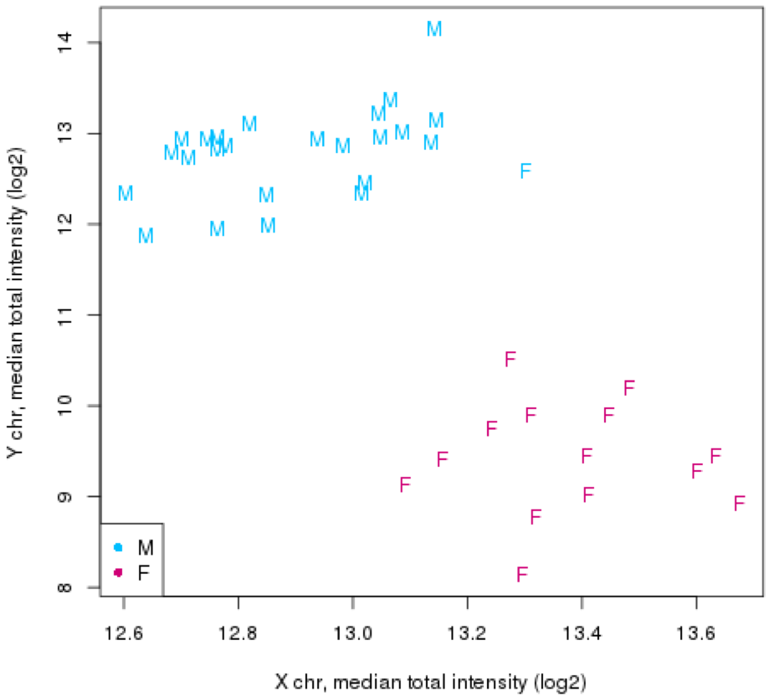
Figure 8 - Gender Comparison

Appendix 1 – DNA Methylation Workflow

Appendix 2 – RNA Analysis Summary
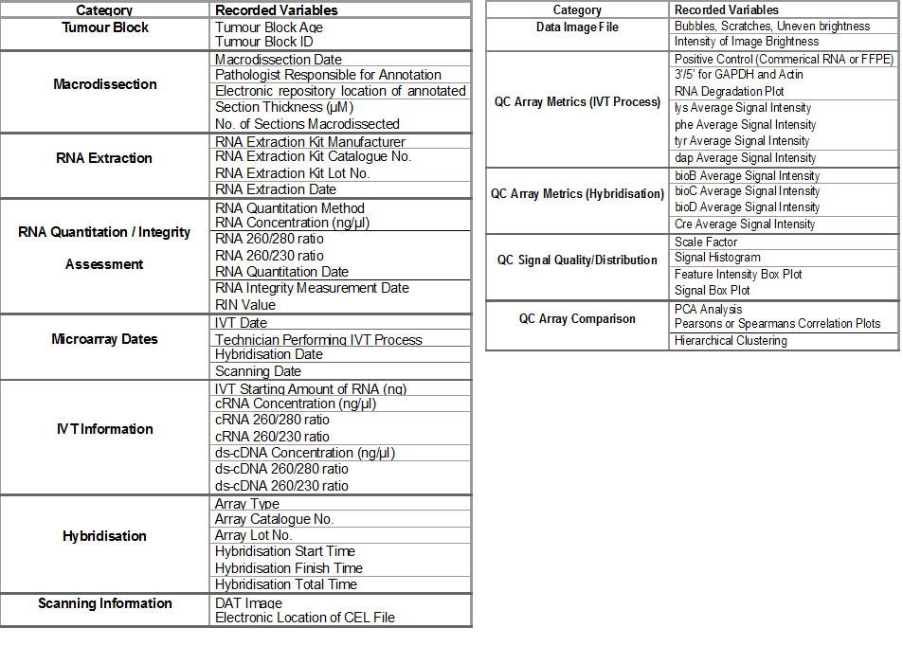

Appendix 3 – Common Patient Data Fields
Identifiers
Name | Example(s)
Pathology lab number | 1234
Unique Sample Identifier at Source Lab | 12770/96-A5
Unique Identifier of Patient | 3243

Patient Data
Name | Example(s)
Age at diagnosis | 72
Date of birth | 22/07/2004
Gender | M, F
Weight | 80.5
Height | 180
Ethnicity | White, Mixed, Asian, Arab
Trial | FOCUS, COIN
Treatment Allocation / Arm / Cohort | A, B, MdG->Ir, OxMdG

Cancer Details
Name | Example(s)
Site of Tumour | Left colon, Right colon, Rectosigmoid junction, Ascending colon, Transverse colon, Caecum
SNOMED Code | 363406005
Bowel screen detected | Y, N
Tumour differentiation | well, moderate, poor
Tumour budding | Y, N
Total number of lymph nodes | 7
Number of positive lymph nodes | 3
Radiological T stage | 0, 1, 2, 3, 4
Radiological N stage | 0, 1, 2
Radiological M stage | 0, 1
Radiological TNM Stage | T0N0
Radiological Extramural Vascular Invasion | Positive, Negative
Pathologist T stage | 0, 1, 2, 3, 4
Pathologist N stage | 0, 1, 2
Pathologist M stage | 0, 1
Pathologist TNM Stage | T0N0
Pathologist Extramural Vascular Invasion | Positive, Negative
Date of Metastasis | 22/07/2004
Liver metastasis | Y, N
Node metastasis | Y, N
Lung metastasis | Y, N
Peritoneum metastasis | Y, N
Other metastasis | Brain, Bone
Dukes stage | C2, A, B
WHO Performance Status | 0, 1, 2
Distance of tumour from circumferential resection margin (mm) | 1, 5, 3
Quality of mesorectal dissection | 1, 2 ,3
Date of randomisation or registration | 22/07/2004
Date of Diagnosis | 22/07/2004
Date of Initial Assessment | 22/07/2004
Baseline sum of longest diameter in target lesions (mm) | 45, 27
Date of Biopsy | 22/07/2004
Cancer Confirmed at Biopsy | Y, N

Surgery/ Details
Name | Example(s)
Excision | Y,N
Date of Surgery | 22/07/2004
Operation type | Resection

Treatment Details
Name | Example(s)
Date of first fraction | 22/07/2004
Date of last fraction | 22/07/2004
RT Duration | Xx days
RT Dose | Xx Gy
RT Fractions | 5,25
Chemotherapy Drug | 5FU, Capecitabine, oxaliplatin
Intent of Chemotherapy | Neoadjuvant, palliative, adjuvant

Outcome Details
Multiple instances of:
Name | Example(s)
Date of Assessment | 22/07/2004
Baseline sum of longest diameter in target lesions (mm) | 45, 27
Response category (RECIST) | PD (progressive disease), SD (stable disease), PR (partial response), CR (complete response), NE (not evaluable)

Name | Example(s)
Best overall response | PD (progressive disease), SD (stable disease), PR (partial response), CR (complete response), NE (not evaluable)
Recurrence | Y, N
Local Recurrence | Y, N
Distant Recurrence | Y, N
Radiological Response to pre-op therapy (mTRG) | complete, good partial, partial, minimal
Pathological Response to pre-op therapy (TRG) as defined by RCPath dataset | 1. no viable tumour cells (fibrosis or mucus lakes only)  2. single cells or scattered small groups of cancer cells  3. residual cancer outgrown by fibrosis  4. minimal or no regression (extensive residual tumour).
Death | Y, N
Date of Death | 22/07/2004
Date of Last Follow up | 22/07/2004
Cause of Death | cancer related, not cancer related
Date of First Progression | 22/07/2004
Overall Survival (Days) | 230
Progression Free Survival (Days) | 170
Molecular Details
Name | Example(s)
Date of Molecular Assessment | 22/07/2004
White Blood Count | 8, 3.2
Platelet Count | 378, 223
Neutrophil | 6.19, 3
Lymphocytes
Bilirubin | 14, 15
ALKP | 229, 216
ALT | 49, 12
AST | 32, 41
Creatinine clearance | 65, 69

Name | Example(s)
Date of Marker Test | 22/07/2004
Raised Tumour Marker | Y, N
Tumour Marker Name | CEA, Ca19.9
Marker Value | 9, 696
Kras Mutation | G12V, G12C, WT
Braf Mutation | V600E, WT
Nras Mutation | Q61K, WT
Pik3ca Mutation | E542K, WT
MMR Status | Positive, Negative
MMR Source | MLH1, MSH2, MSH6, PMS2

References

Primrose, J., Falk, S., Finch-Jones, M., Valle, J., O’Reilly, D., Siriwardena, A., … Bridgewater, J. (2014). Systemic chemotherapy with or without cetuximab in patients with resectable colorectal liver metastasis: the New EPOC randomised controlled trial. The Lancet Oncology, 15(6), 601–611. https://doi.org/10.1016/S1470-2045(14)70105-6
Seymour M.T.a Maughan, T. S. . L. J. A. . T. C. . J. R. . G. S. J. . S. D. B. . S. S. . M. A. . F. D. R. . M. A. M. . T. L. . G. G. O. . P. M. K. . S. R. J. . (2007). Different strategies of sequential and combination chemotherapy for patients with poor prognosis advanced colorectal cancer (MRC FOCUS): a randomised controlled trial. Lancet, 370(9582), 143–152. https://doi.org/10.1016/S0140-6736(07)61087-3

